CS4335 Tutorial Week 4 Student Name Student Id:

Question 1: Use Dijkstra’s algorithm to find the shortest path from s to . v. for the following graph. Backtracking is required.

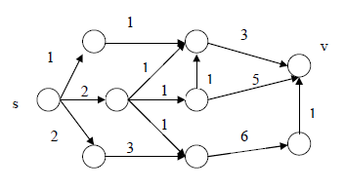

Answer:

